Test Case: runTestMultipleTimes
Step 1 - Enter username and password and click to button Enter : Credentials Entered
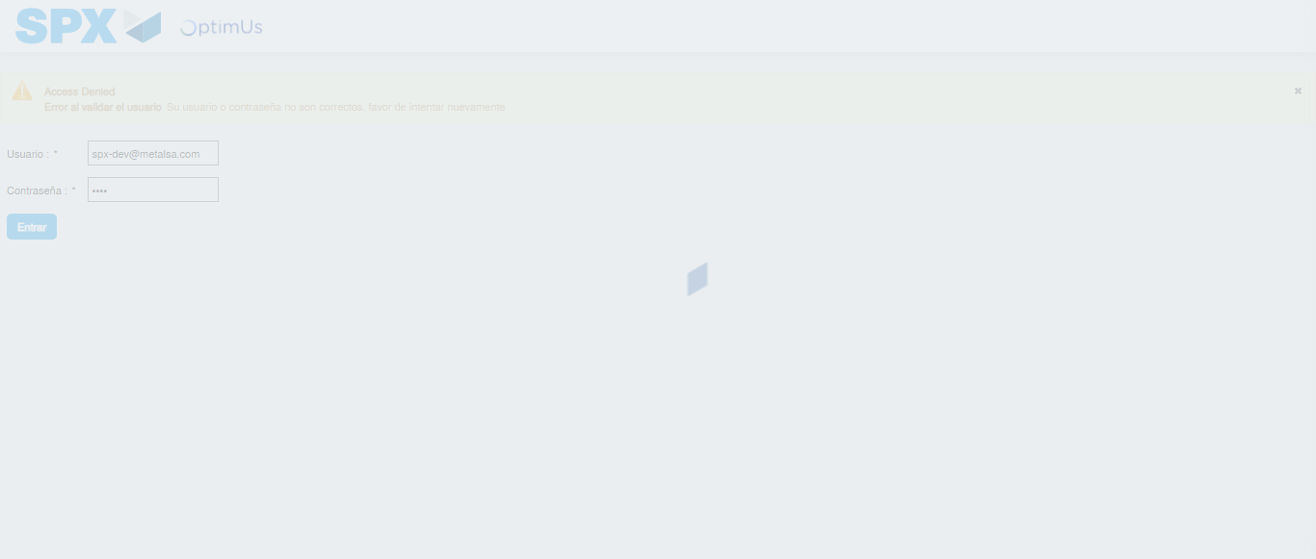Image file-name: QC_Testing-runTestMultipleTimes-dic. 04 2025, 03 40 47 p. m.

Step 2 - Select to UEN and Access to Administrador Roles Menu: UEN Correctly selected and Correct access
Image file-name: QC_Testing-runTestMultipleTimes-dic. 04 2025, 03 40 50 p. m.

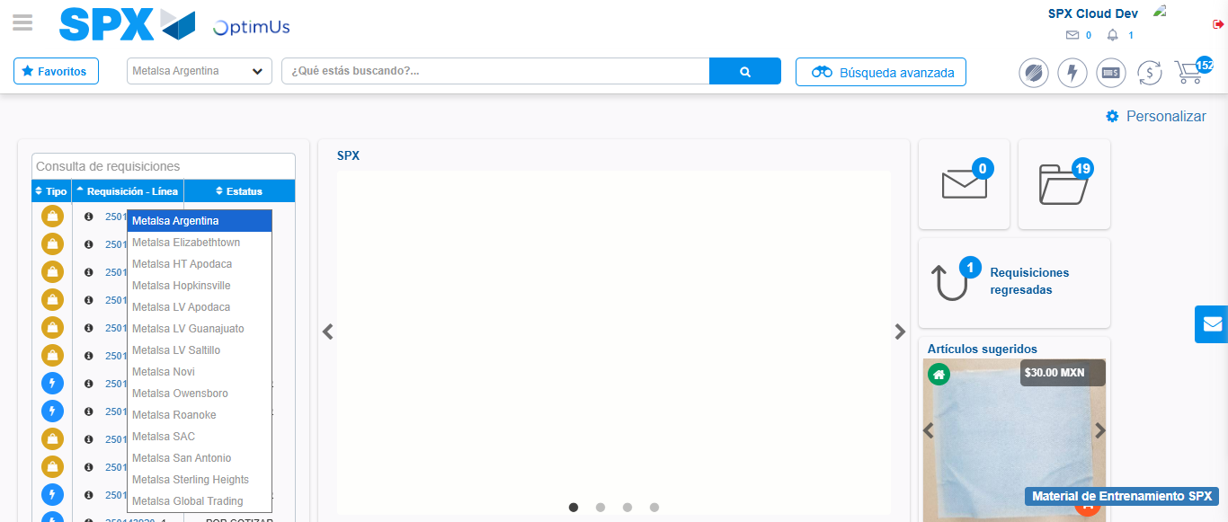Image file-name: QC_Testing-runTestMultipleTimes-dic. 04 2025, 03 40 52 p. m.

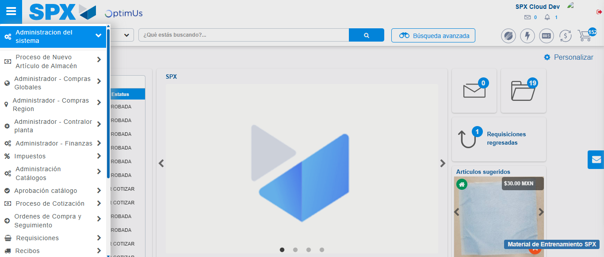Image file-name: QC_Testing-runTestMultipleTimes-dic. 04 2025, 03 40 53 p. m.

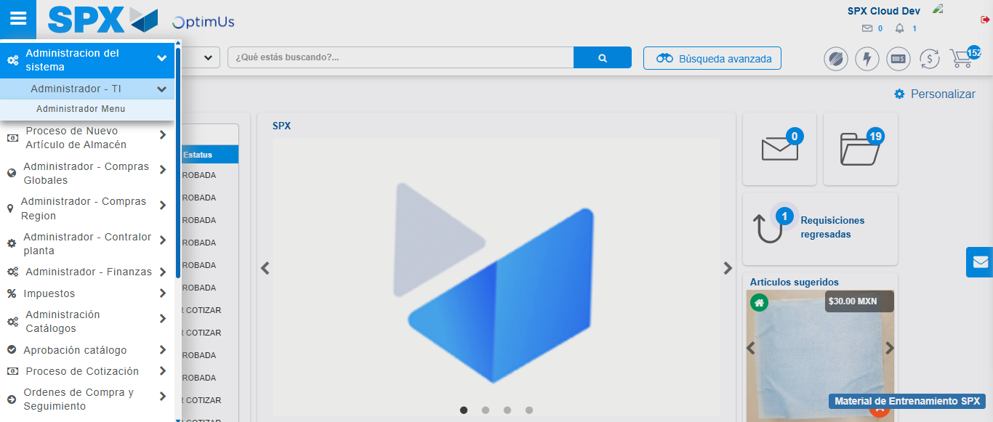Image file-name: QC_Testing-runTestMultipleTimes-dic. 04 2025, 03 40 54 p. m.

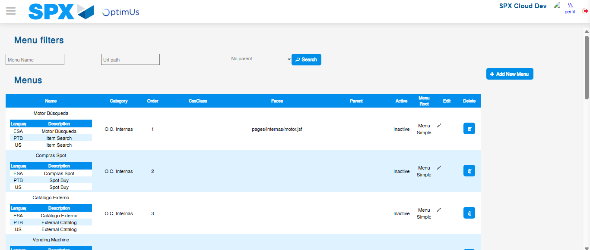Image file-name: QC_Testing-runTestMultipleTimes-dic. 04 2025, 03 40 56 p. m.

Step 3 - Delete record: Record successfully deleted
Image file-name: QC_Testing-runTestMultipleTimes-dic. 04 2025, 03 40 56 p. m.

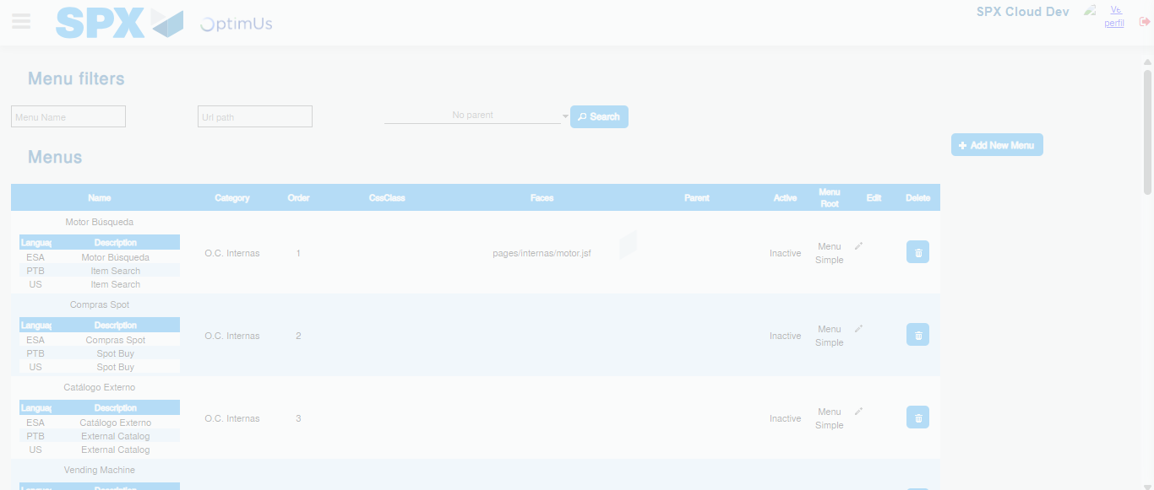Image file-name: QC_Testing-runTestMultipleTimes-dic. 04 2025, 03 40 57 p. m.

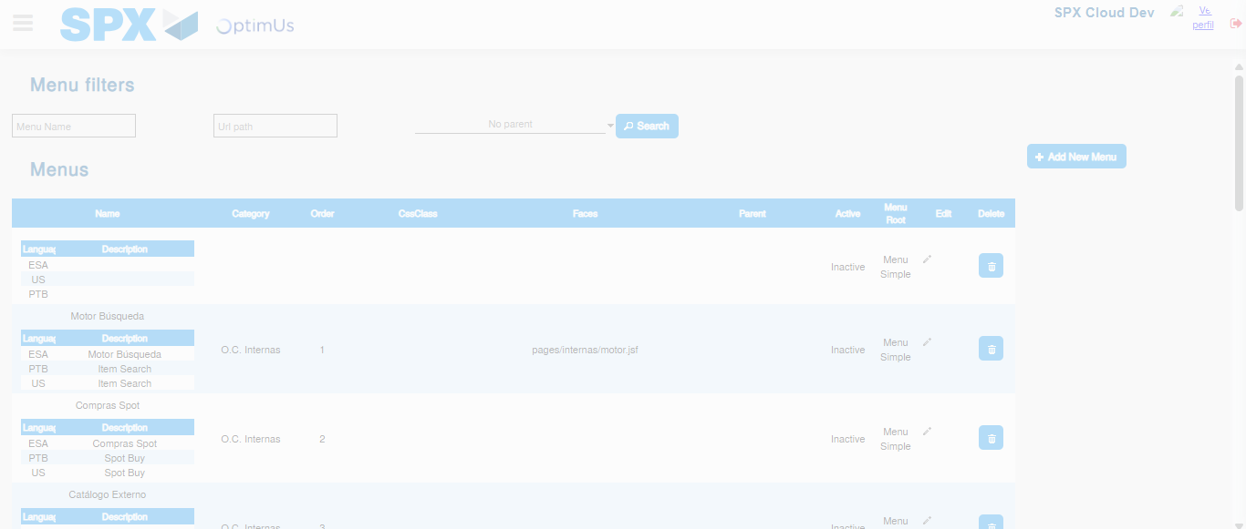Image file-name: QC_Testing-runTestMultipleTimes-dic. 04 2025, 03 41 00 p. m.

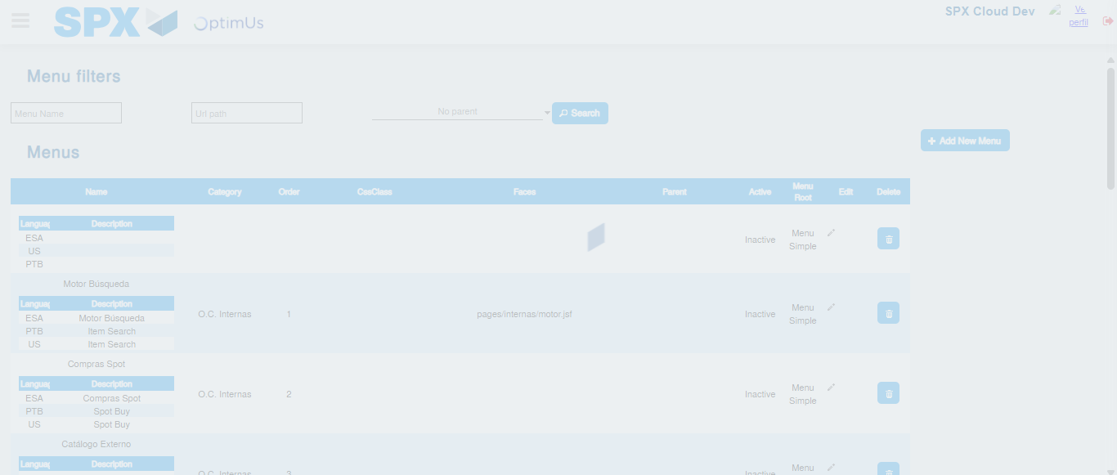Image file-name: QC_Testing-runTestMultipleTimes-dic. 04 2025, 03 41 01 p. m.

